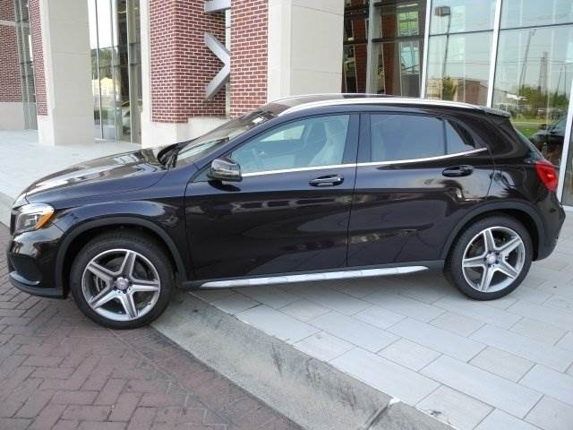
$44,225 7 years 4.7% interest rate
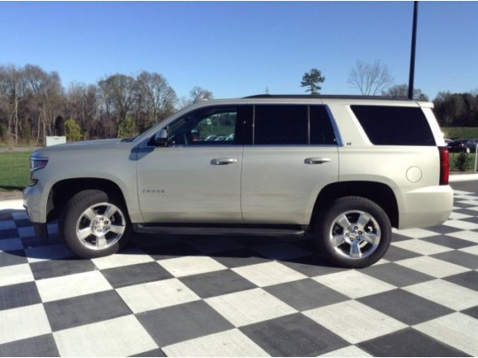
$56,705
8 years
4.5%
Interest rate
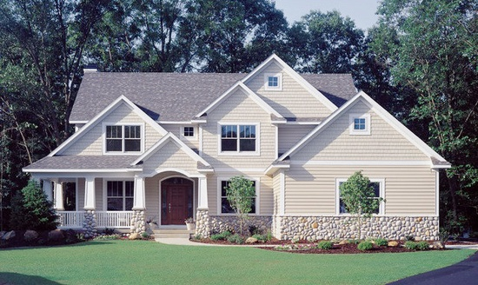

Mayfield:
5 beds; 4 baths; 3,372 sq ft

$550,000; 25 years;
4.3% interest rate
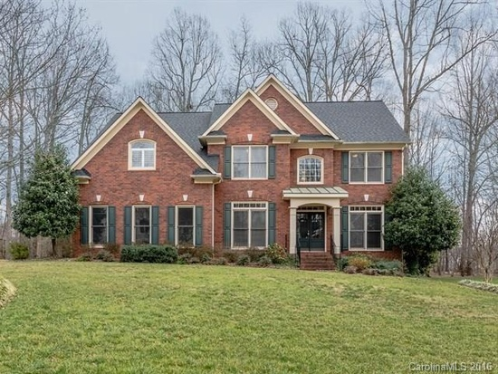
Hampton:
5 beds; 4 baths; 3,506 sq ft

$470,000; 23 years;
4.2% interest rate
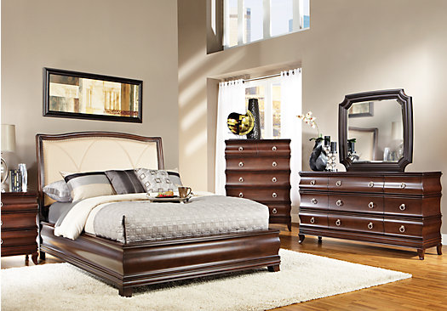
Alexi:
5 piece bedroom set

$1,288; 9 months;
3.8% interest rate
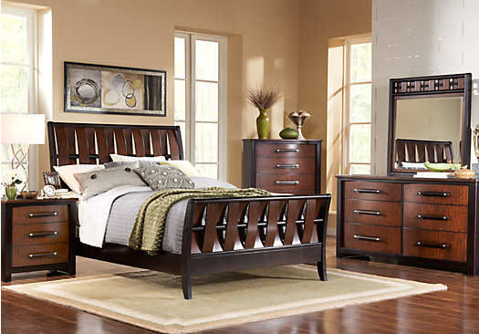
Sleigh:
5 piece bedroom set

$1,130; 9 months;
3.3 % interest rate
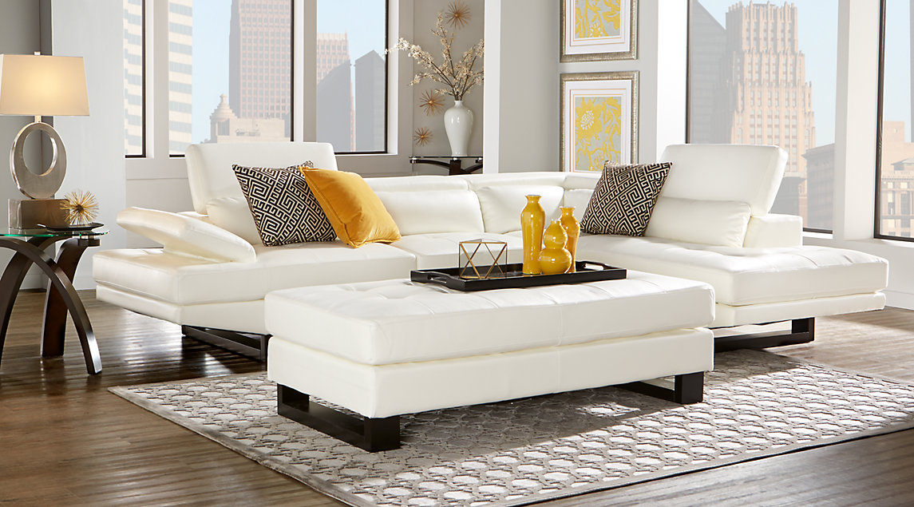
Shiloh:
3 piece living room set

$1,050; 6 months;
3% interest rate
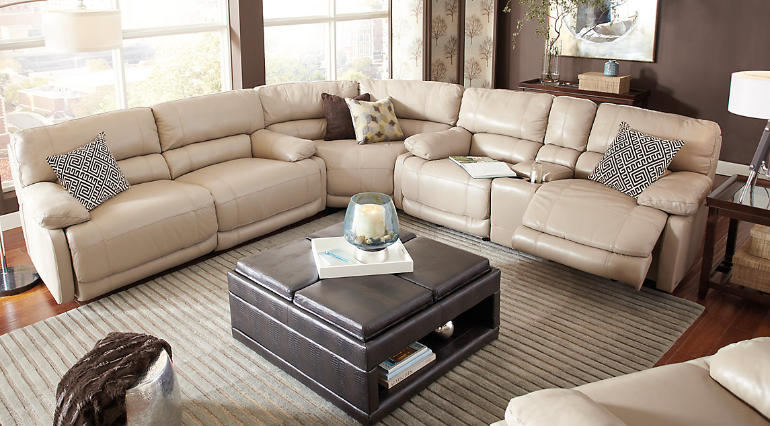
Auburn Hills:
3 piece sectional

$1,300; 6 months:
3.2 % interest rate
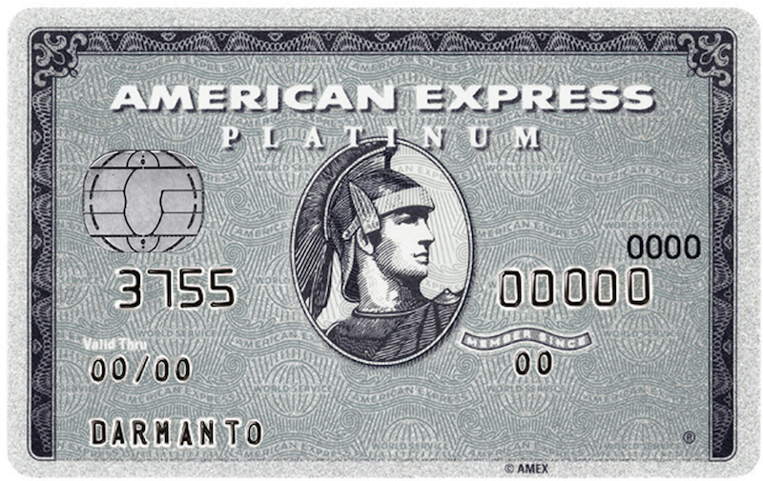
$3,000
14 months
4% per month

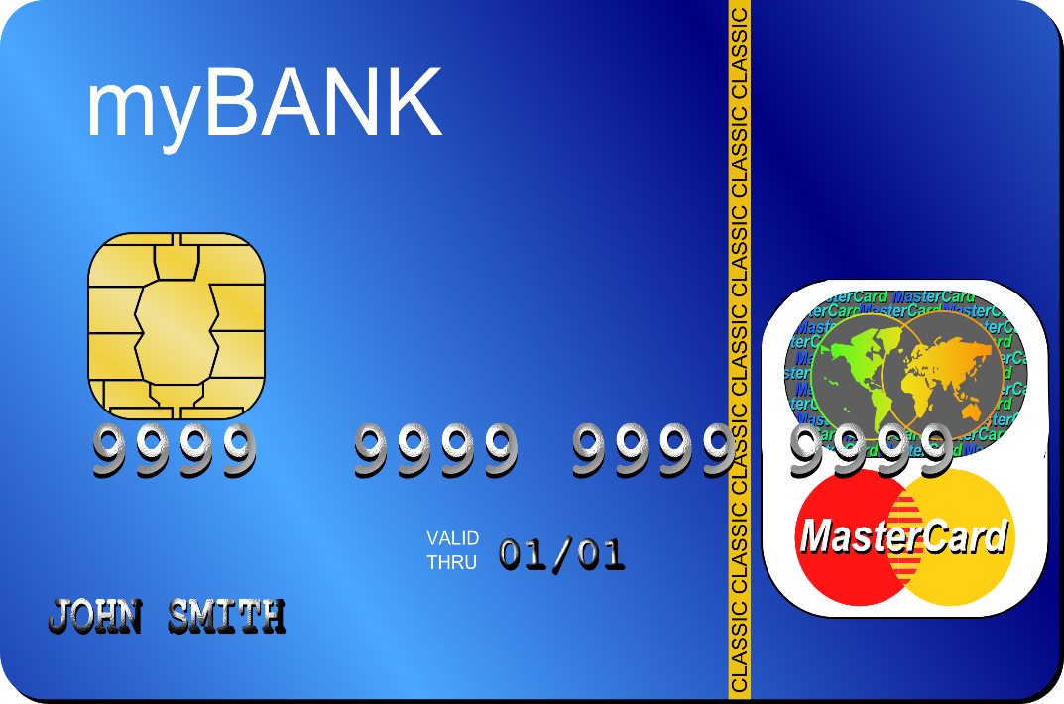
$3,500
16 months
4 % per month

