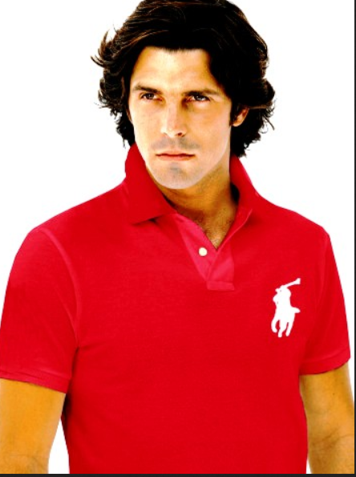
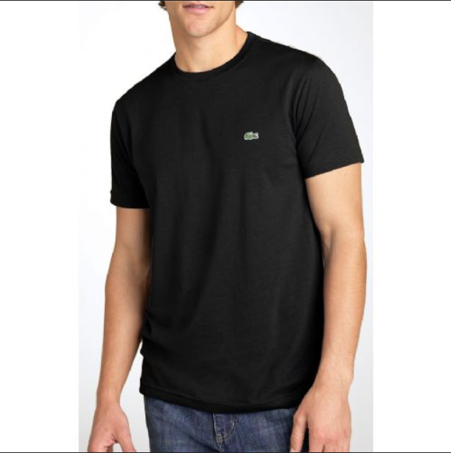

Item | Price | Discount
Red Polo | $45.99 | 10%
Black Lacoste | $48.49 | 12%

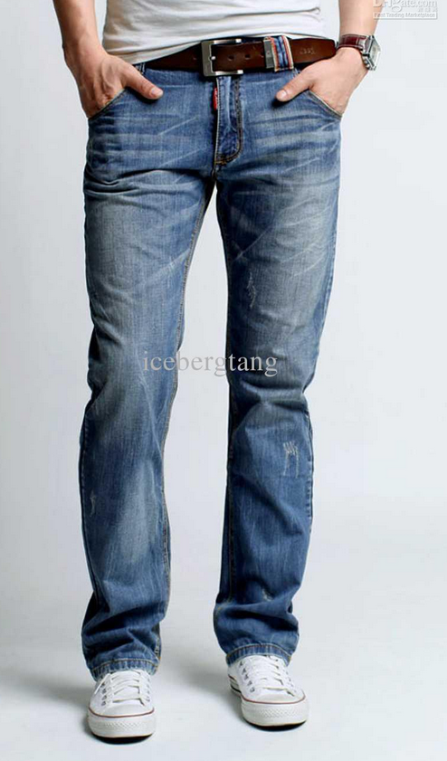

Item | Price | Discount
Jeans | $29.89 | 10%
Shorts | $25.29 | 8%

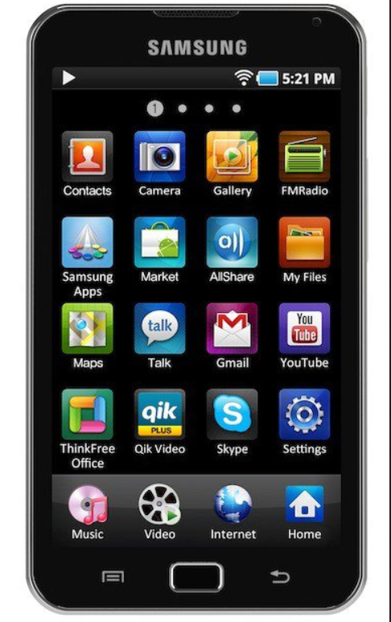
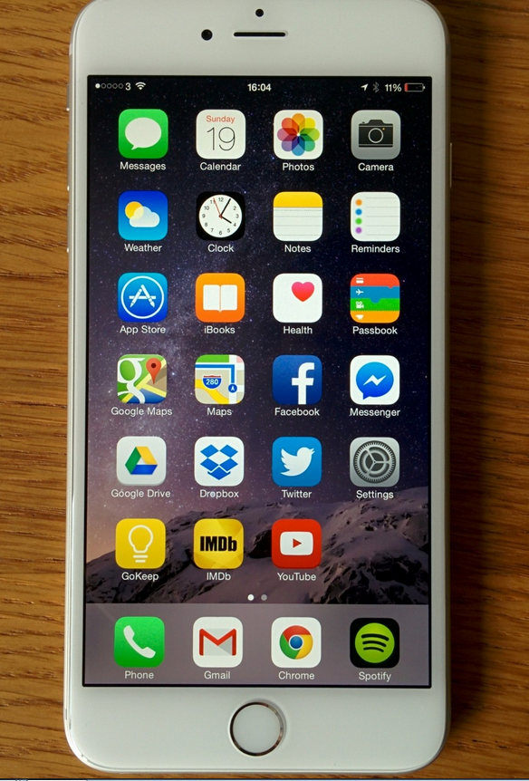

Item | Price | Discount
I-Phone | $854.99 | 7%
Samsung | $694.01 | 2%

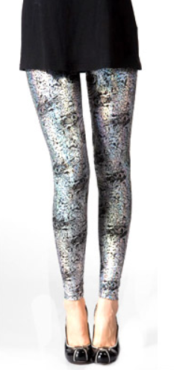
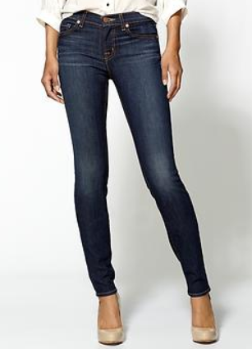

Item | Price | Discount
Skinny Jeans | $32.55 | 14%
Leggings | $19.99 | 11%

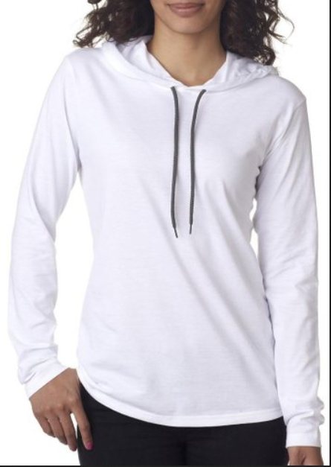
Item | Price | Discount
Blue Tee | $17.99 | 7%
White Hoodie | $36.50 | 20%

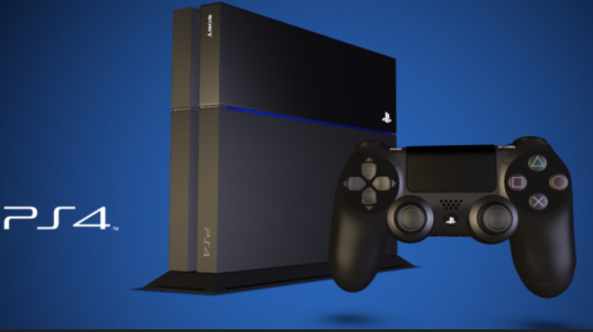
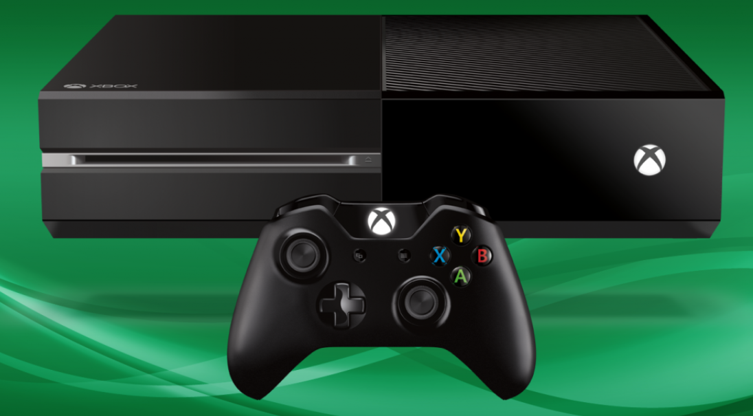

Item | Price | Discount
Xbox One | $325.48 | 20%
PS4 | $299.48 | 18%

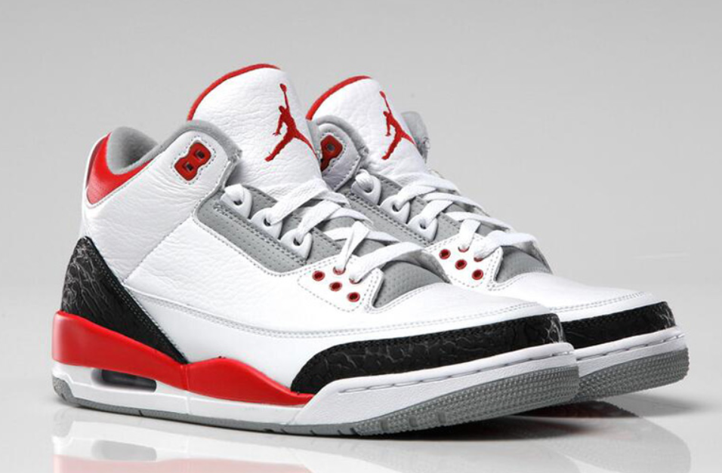

Item | Price | Discount
Jordans | $169.89 | 4%
Converse | $44.99 | 1%

