Name ___________________________________ Date ___________ Block R Y G B

Inequalities Quiz

- x < - 9 True or False: -63 can be a solution to this inequality?
7

SOLVE AND GRAPH

- -4v + 85 > 240
- -3(2e – 5) -16 ≥ -169
- -56 > -8m
- – p - 3p(14-7) + 197 ≤ -8p -32 + 10
- –b ≥ 7
7
- Write the inequality for the graph below. 8) Graph the inequality below
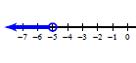
a)
a)
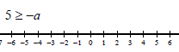
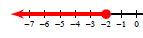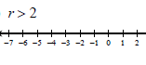
b)
b))

Translate and solve.
- Negative 12 is greater than the quotient of a number and 3.
- Eleven is less than or equal to the product of a number an 14.

