Exponential Functions and Rational Exponents
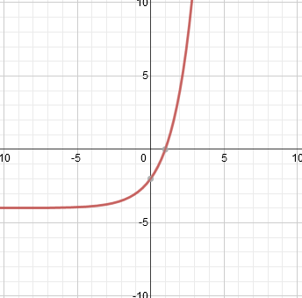
- The function f(x) = 2(2)^{x} was replaced with f(x) + k, resulting in the graph below. What is the value of k?

- Write as a radical expression: ${(64x^{2}y^{3})}^{\frac{-1}{2}}$
- 8xy^{3/2} b.$\frac{8}{xy^{\frac{3}{2}} }$ c. $\frac{1}{8xy^{\frac{3}{2}}}$ d. $4xy^{3}$

- Which of the following is not true regarding the function y = 2^{x}:
- The function is an exponential function
- The function has a domain of all real numbers
- As the value of x gets very large the value of y gets close to zero
- As the value of x increases by one the value double

- If a student deposits $1500 in the bank and earns an annual interest rate of 8% how much will he have after 15 years?

- Which of the following is true for y = .5(3) ^{x} :
- The function shows exponential growth.
- The function shows exponential decay.
- The function is a linear function.
- The y intercept is 3.

- The population of Barnardsville in 2014 was estimated to be 24,000 people with an annual rate of increase (growth) of about 2.4%. Which function would give you the estimated total population, y, of Barnardsville in 2021?
[A] y = 24000 (1 + 2.4)7 [C] y = 24000 (1 + .024)⁷
[B] y = 24000 (1+ 2.4)²¹ [D] y = 24000 (1 + .24)²¹

7. Matt bought a new car at a cost of $28,000. The car depreciates approximately 15% of its value each year. Which function would give you the estimated value of the car, y, after t years?
[A] y = 28000 (.15)^{t} [B] y = 28000 (1.15)^{t} [C] y = 28000 (.85)^{t} [D] y = 28000 (1.015)^{t}

8. Kelly plans to put her graduation money into an account and leave it there for 4 years while she goes to college. She receives $900 in graduation money that she puts into an account earning 4.25% interest annually. How much will be in Kelly’s account at the end of four years?
[A] $1,052.87 [B] $1,063.03 [C] $3,711.09 [D] $293,628.5
9. Maggie recorded the population for two different cities in North Carolina. The results are shown in the table below
Time  (years) | City 1, NC | City 2, NC
2008 | 950 | 150
2010 | 1,248 | 299
2012 | 1,551 | 598
2014 | 1,862 | 1196
Which statement best describes her data?
[A] Both cities’ population changed at a constant rate.
[B] Both cities’ population changed at an exponential rate.
[C] City 1 increased its population at a constant rate, and City 2 increased its population at an exponential rate.
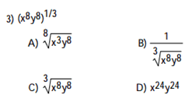
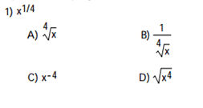
[D] City 1 increased its population at an exponential rate, and City 2 increased its population .

